ShopHub

___________________________________________

Website Documentation

Admin Guide

___________________________________________

Student Name: Nischal Aryal

Student ID: 77261069

Module Name: Production Project

1. Admin is redirected to the admin’s dashboard after entering their username i.e., Email and Password

* Valid login credentials.

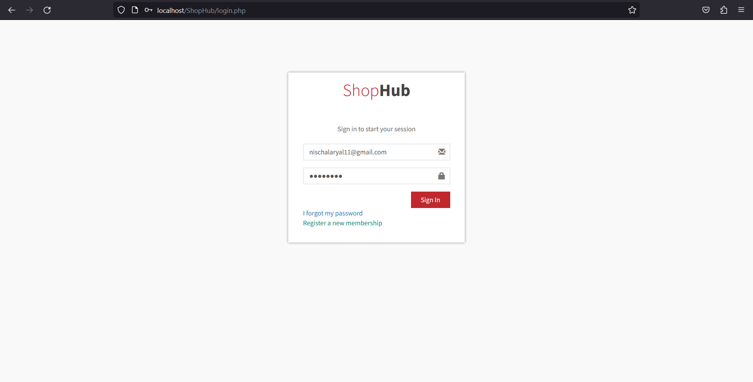

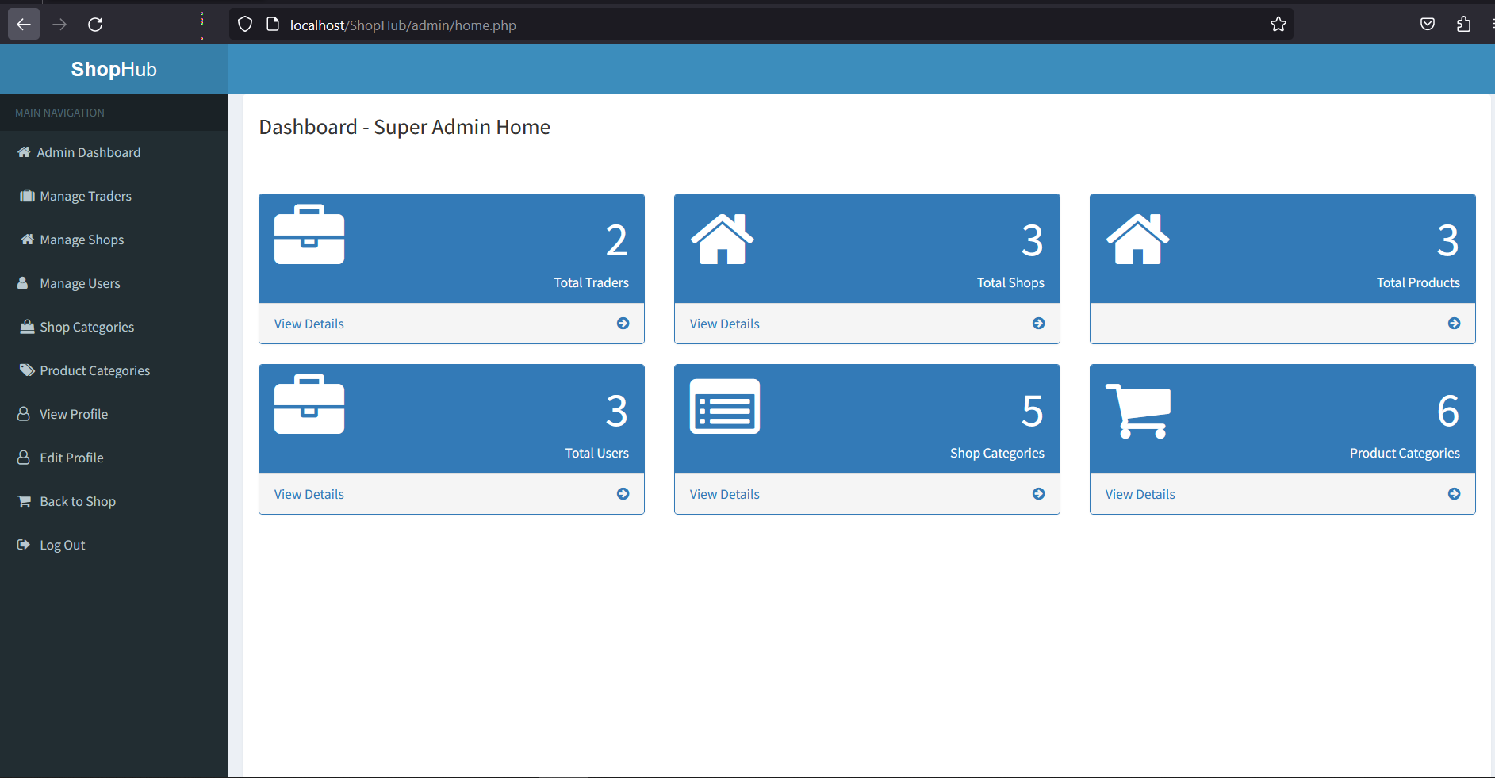

* Invalid login credentials.

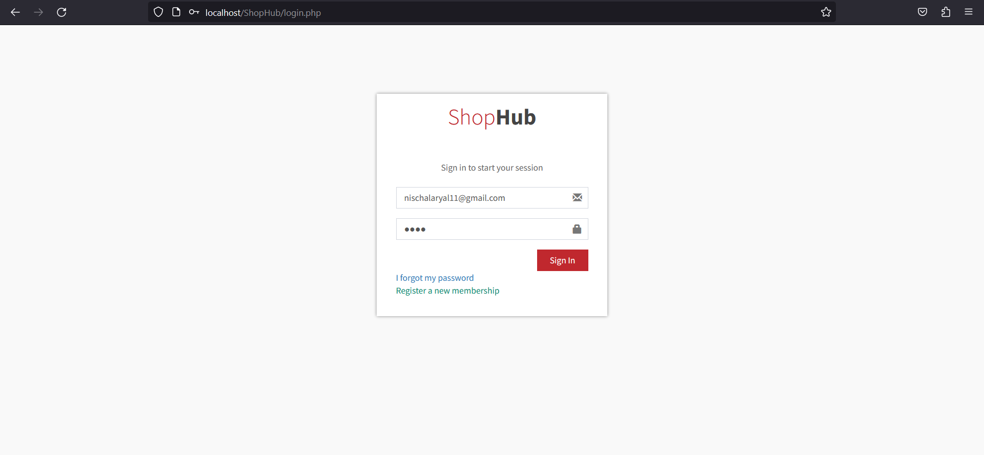

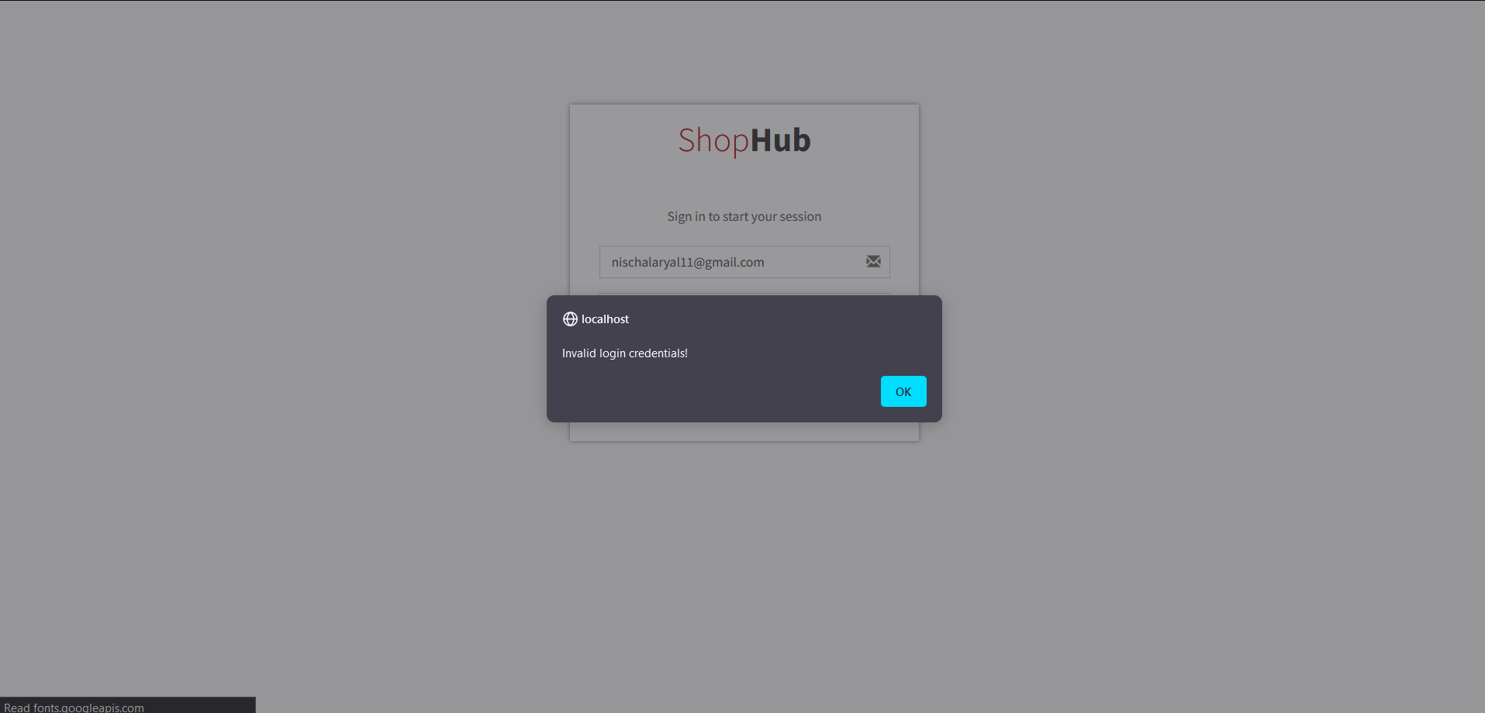

1. After logging in with the correct login details as Admin, you’ll have access to the trader’s and customer’s information, details of shop and products, activate/deactivate the trader’s and customer’s accounts and shops.

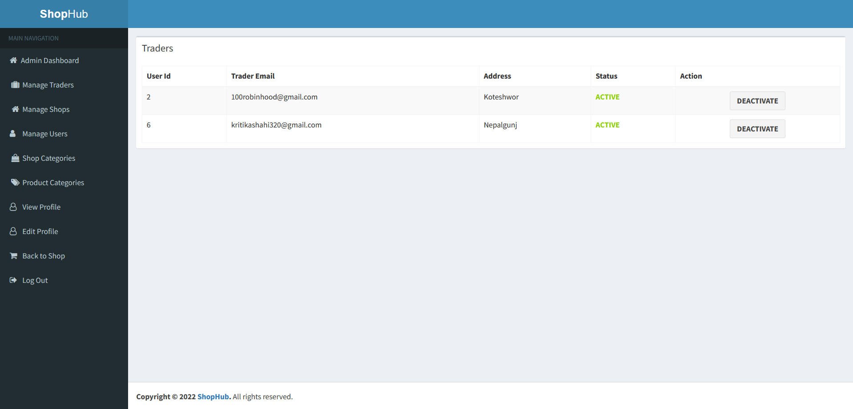

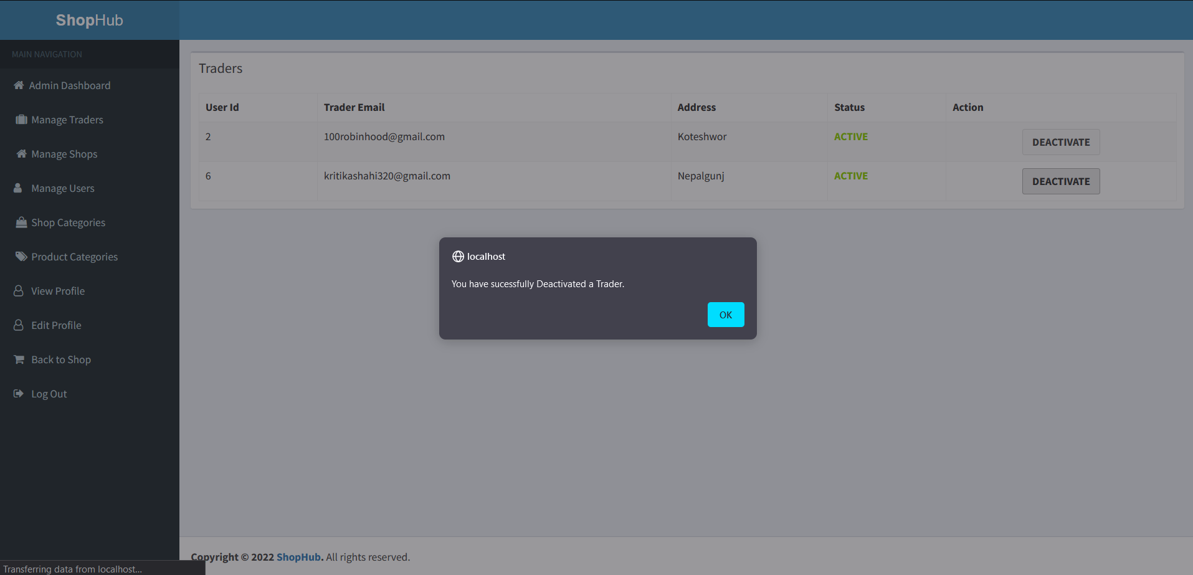

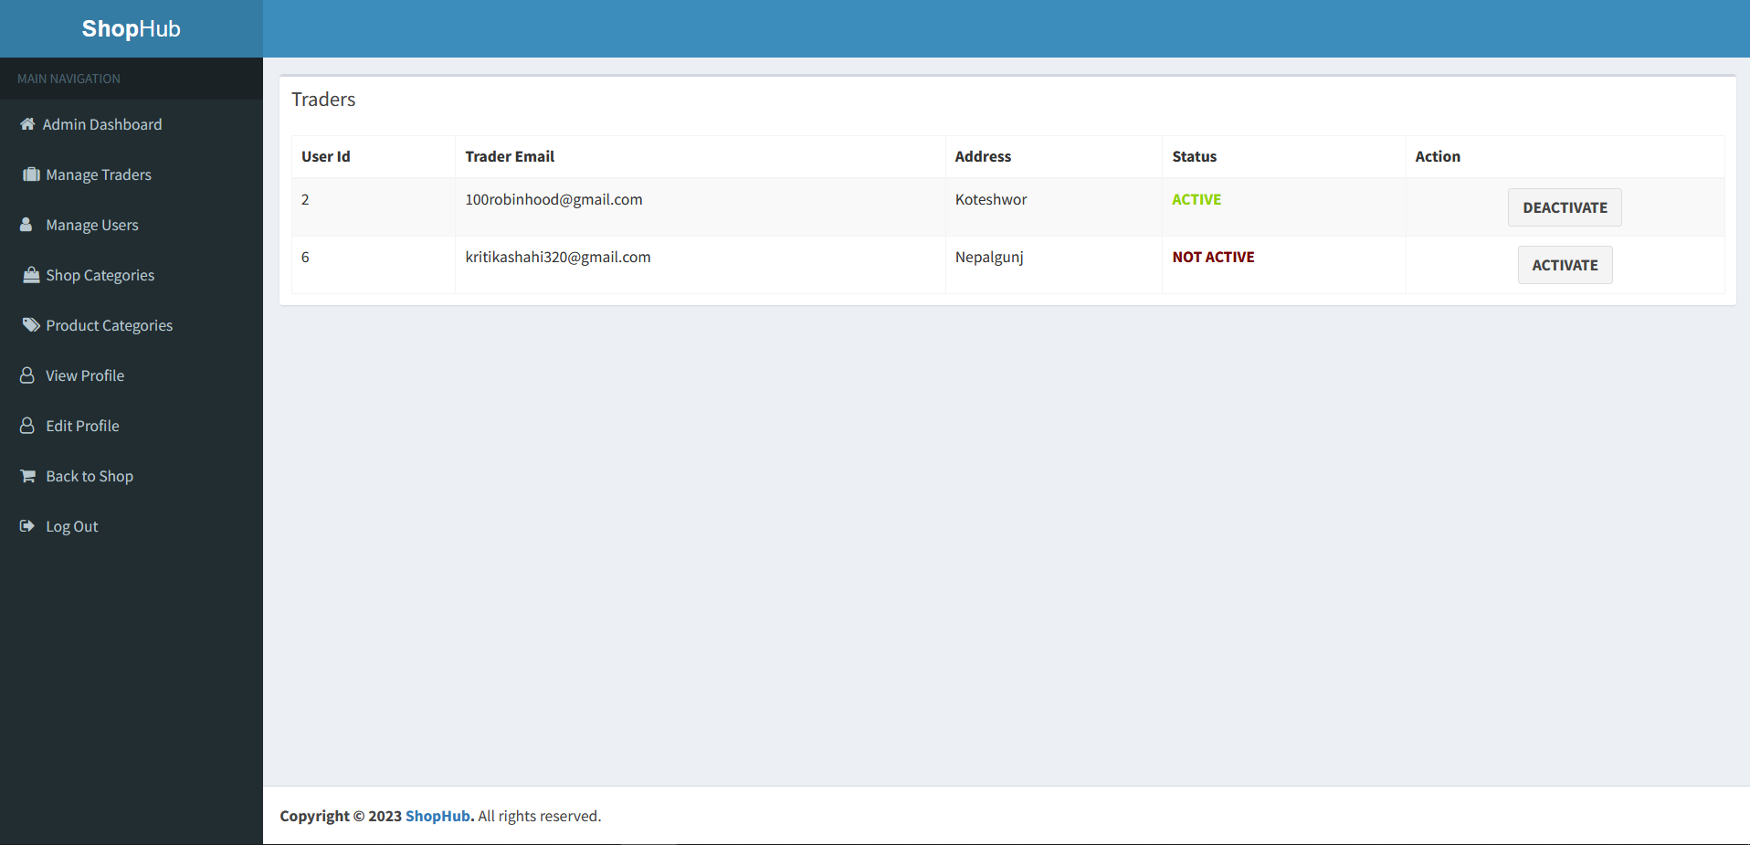

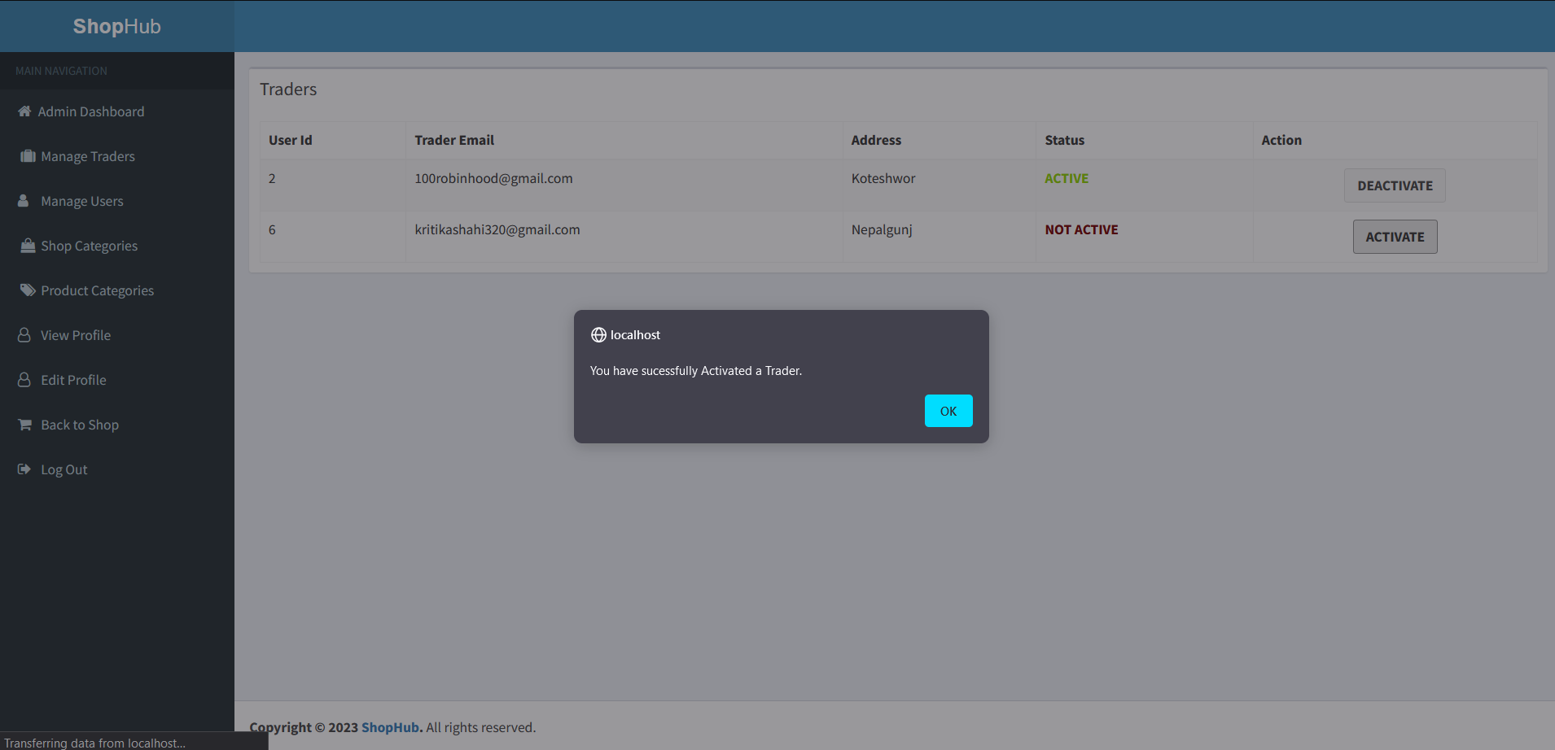



* Admin can manage product’s as well as shop’s category.

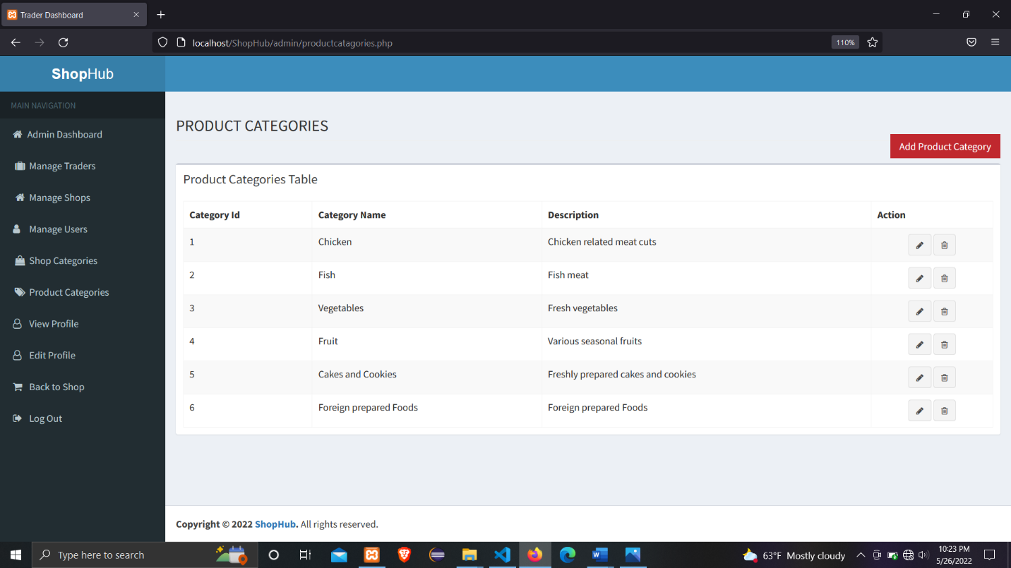

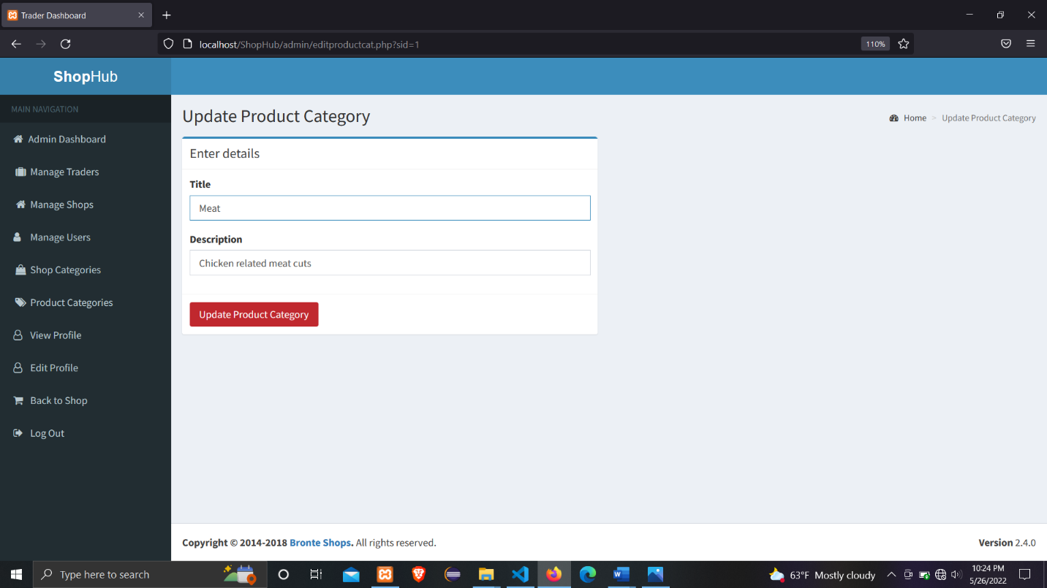

Fig: Updating Product’s category from Chicken to Meat

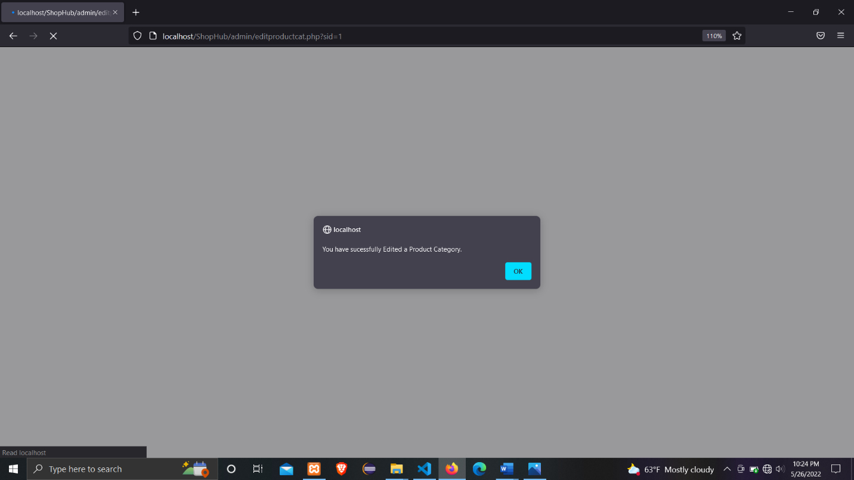

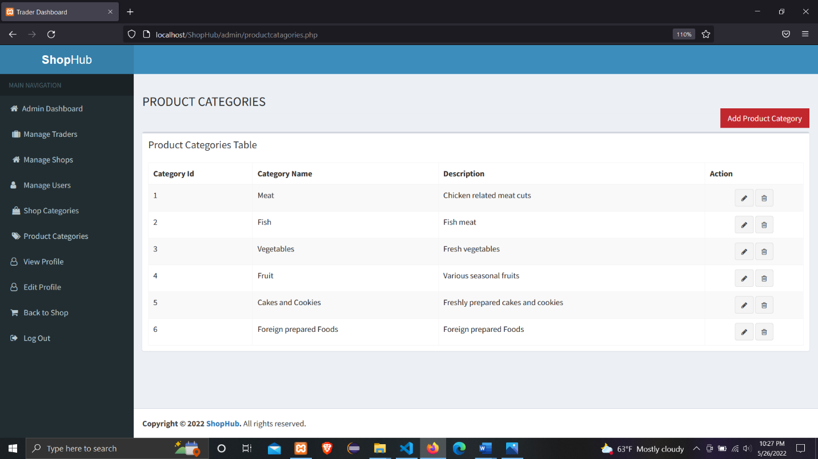

* Admin can manage their profile

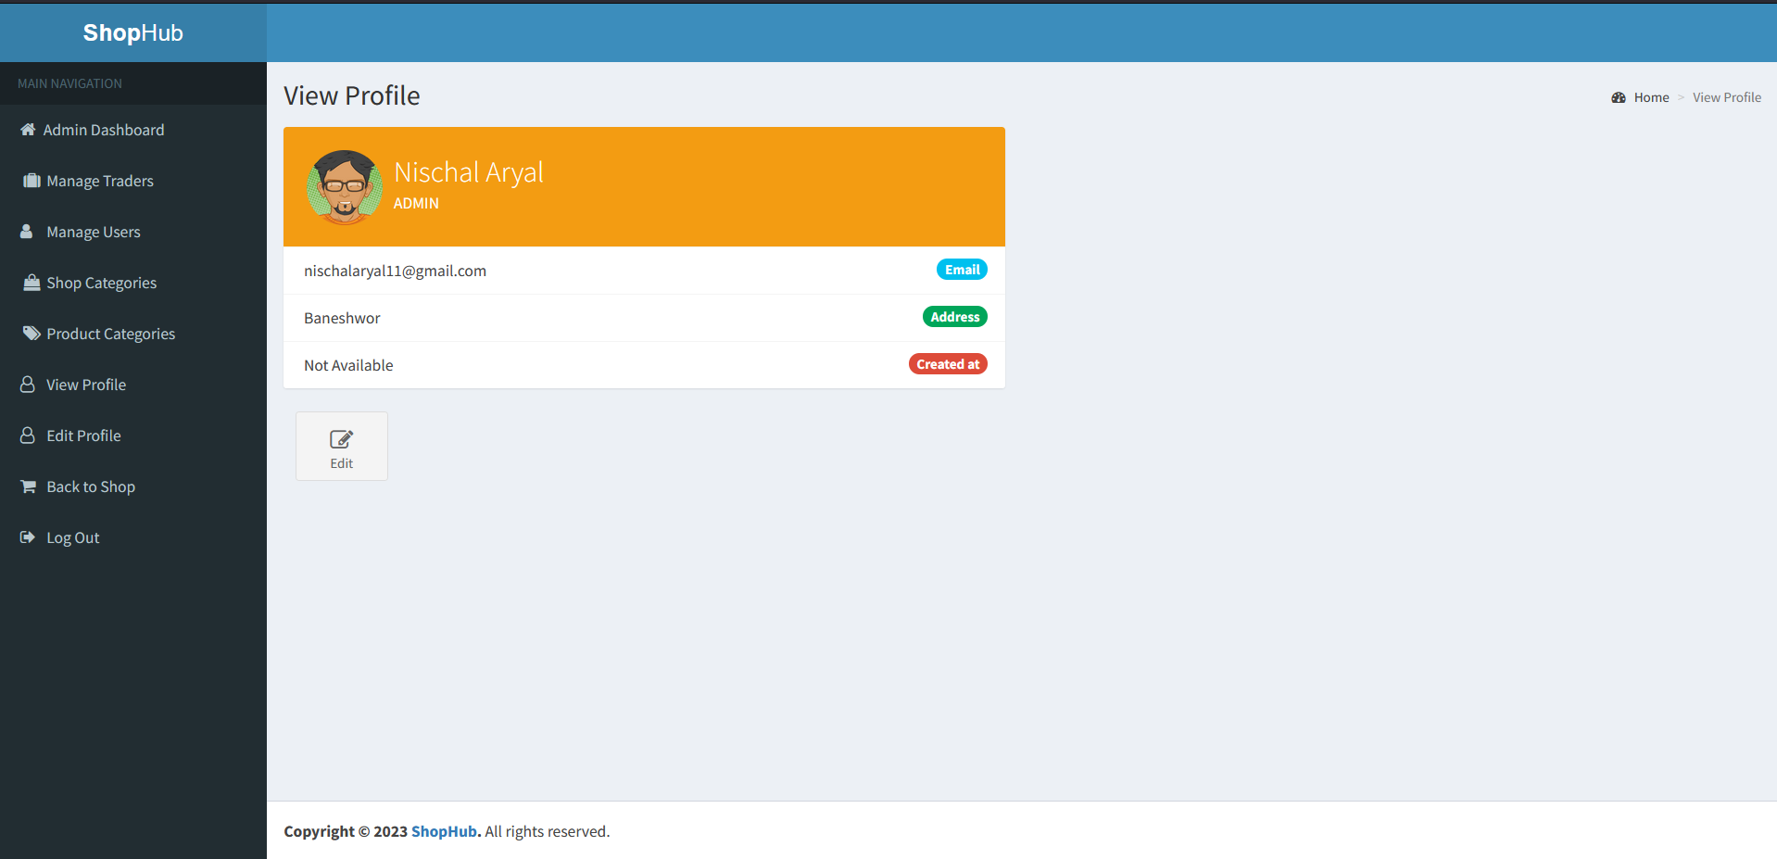

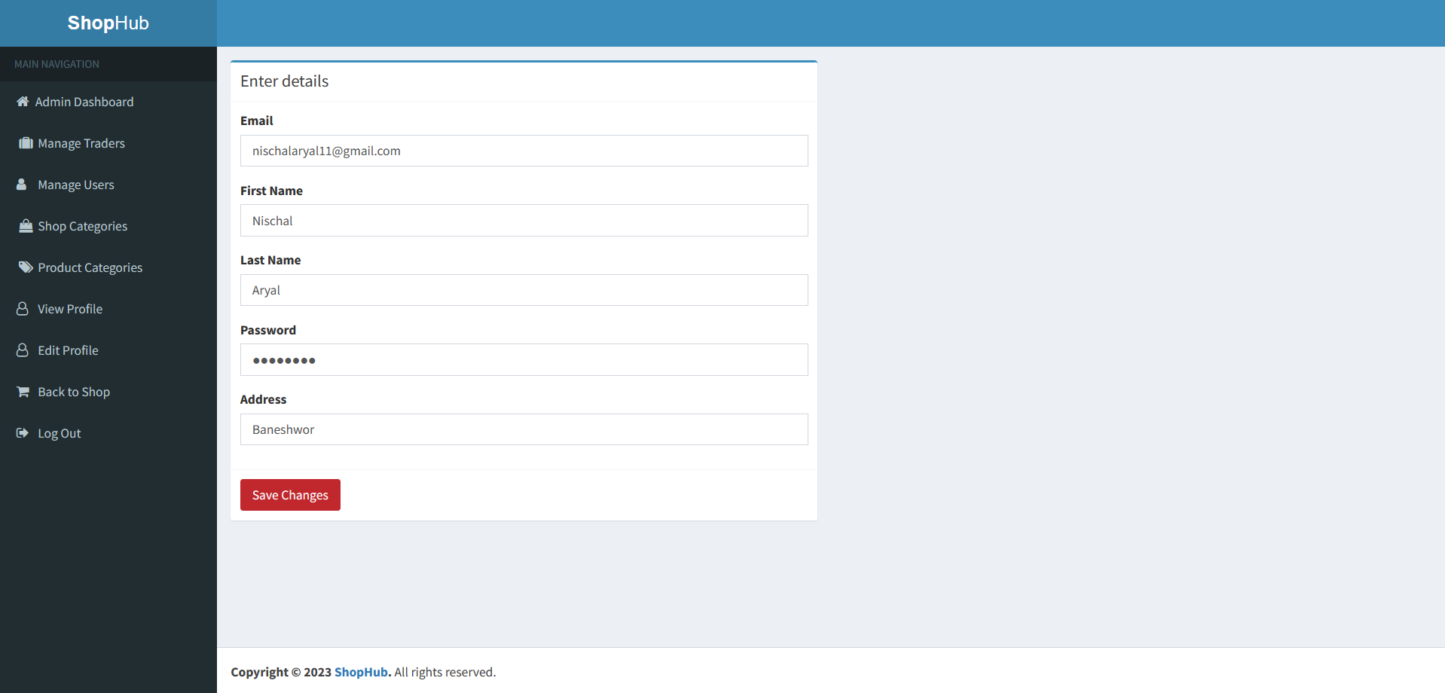

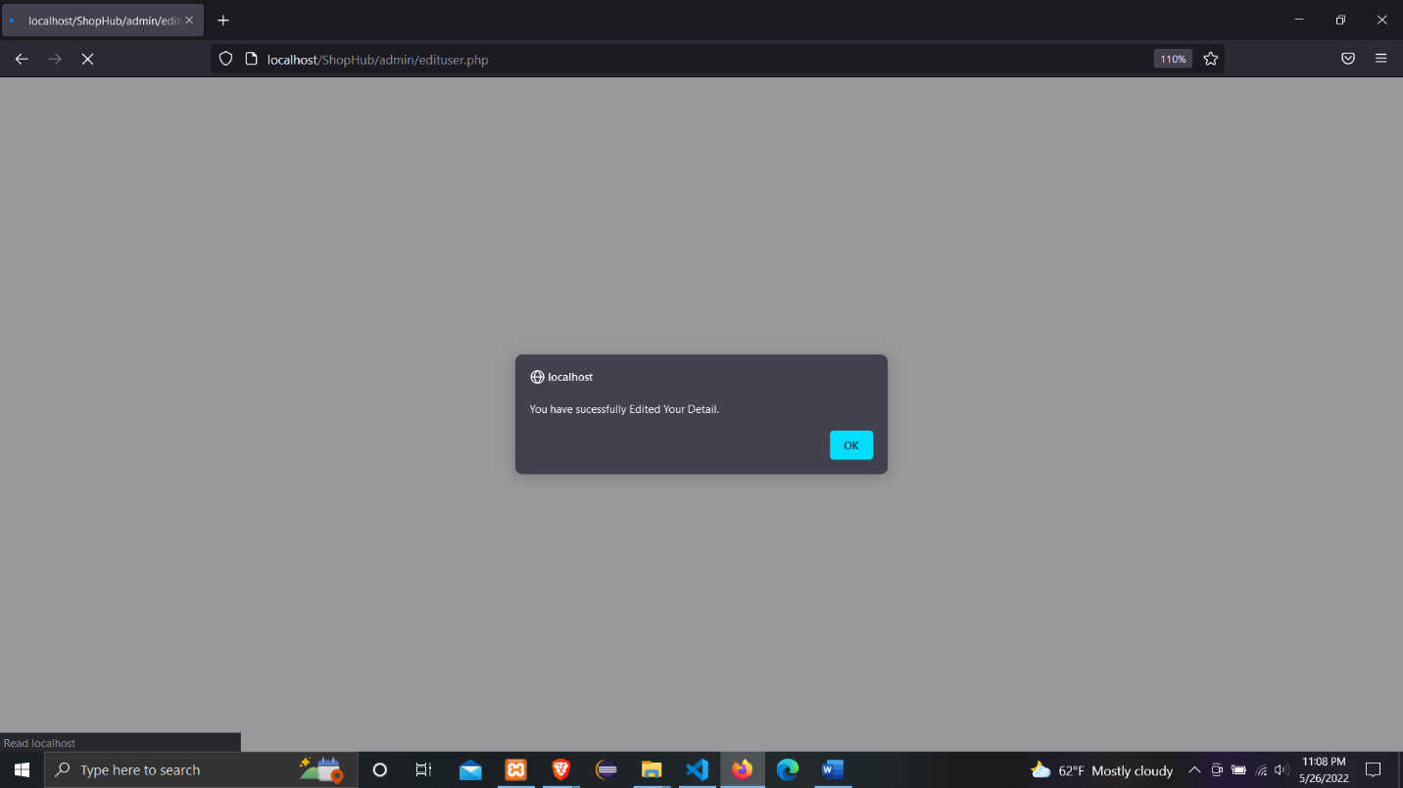



Fig: Updating Address of Admin previously Nepalgunj now Kathmandu

* Admin can view total number of Shops, Traders, Users, Products, Shop Categories, Product Categories from admin Dashboard.



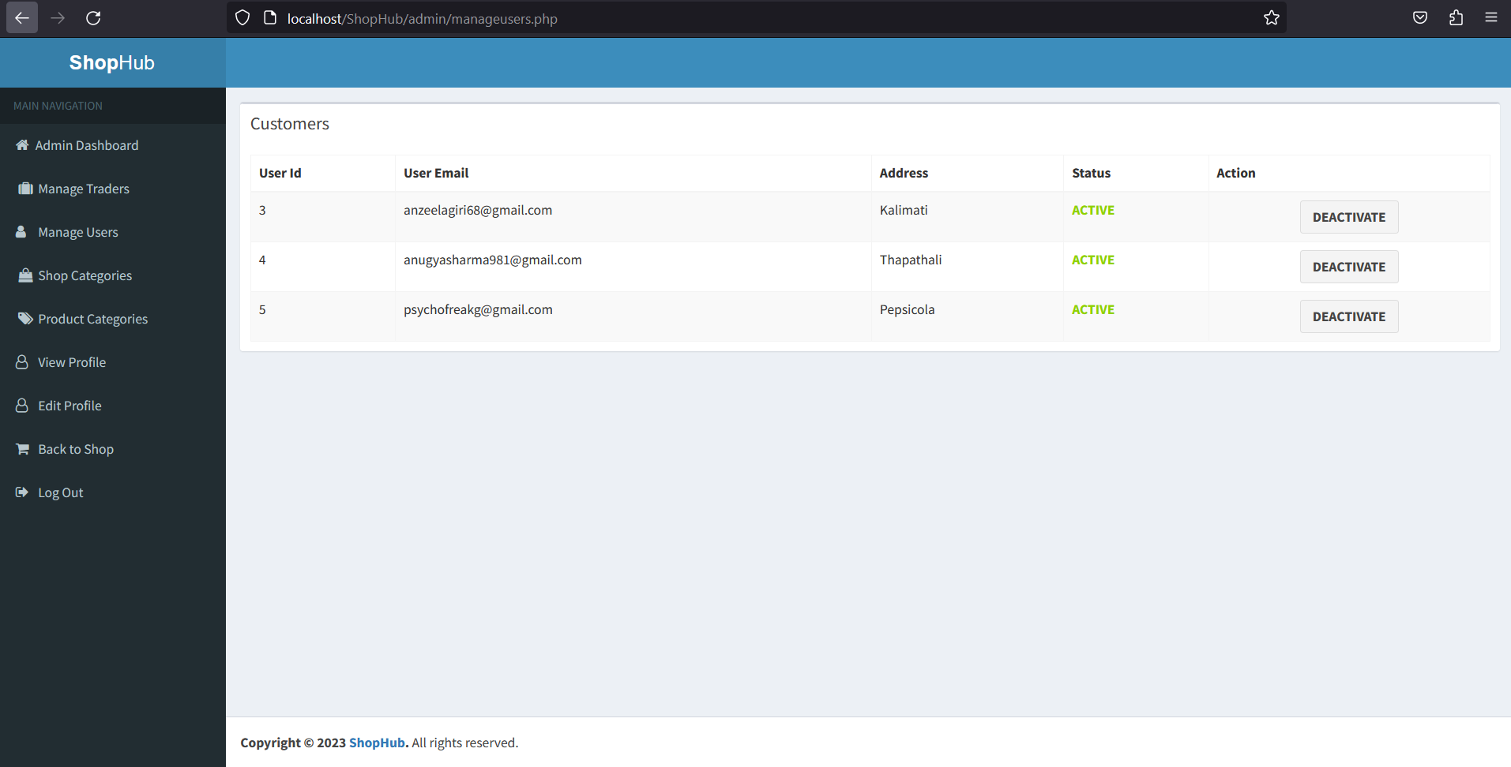

Fig: Total number of registered customers

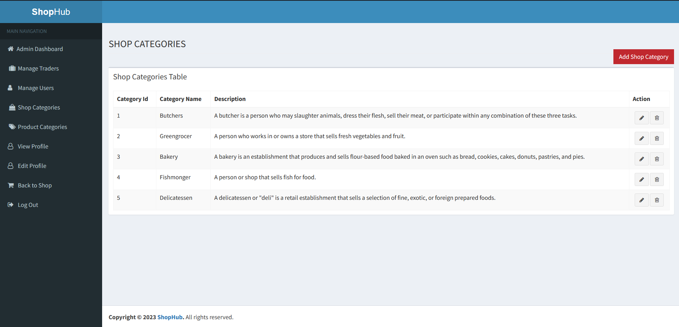

Fig: Total number of Shop Categories

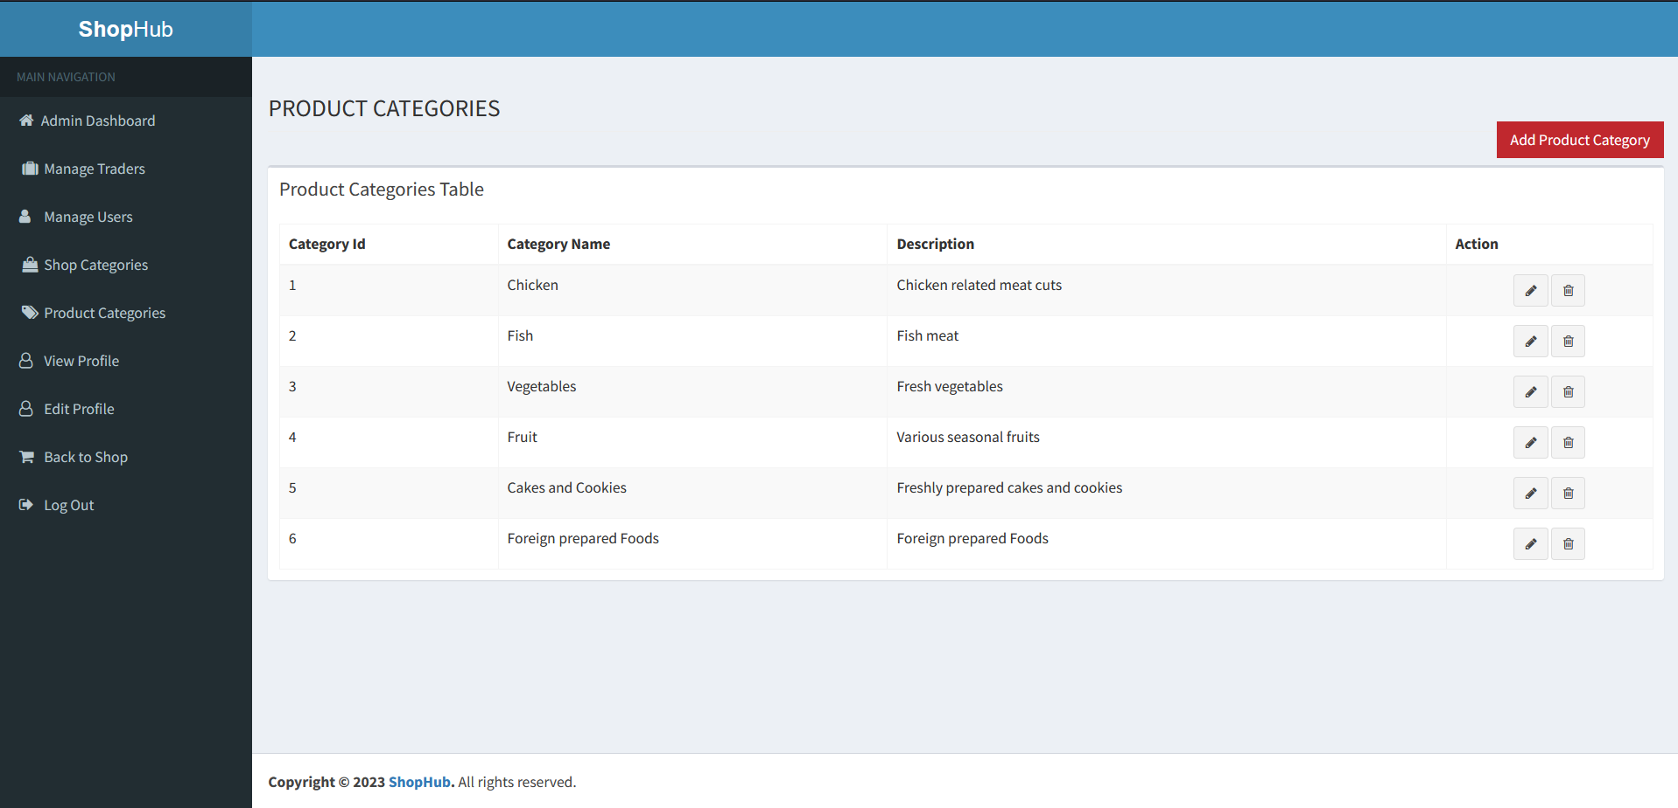

Fig: Total number of Product Categories

* Admin can go back to the shop and inspect the changes made.

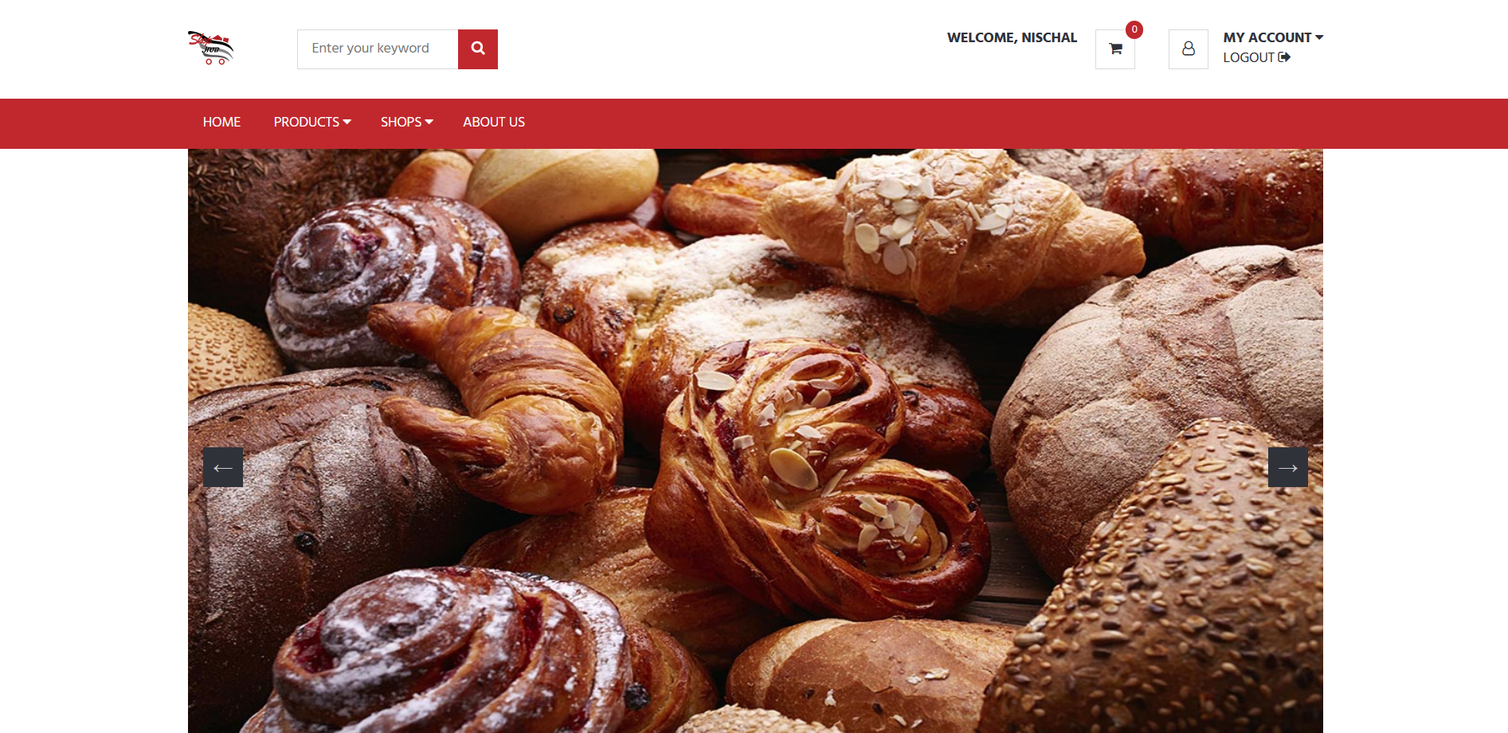

* Admin can log out of their account using logout button.

